**Sriharsha Vemugunta,** 02158051.

Compiling java files

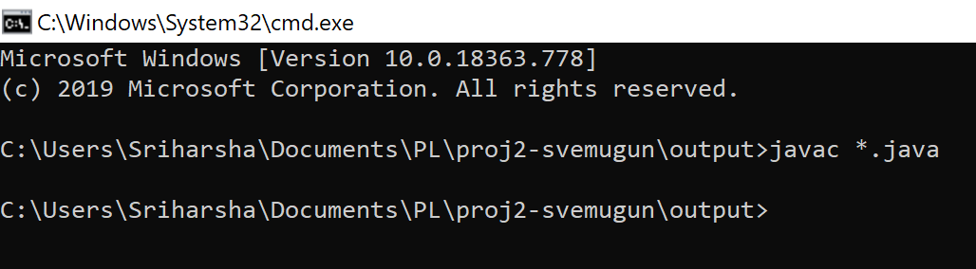

Not Expression: !true;

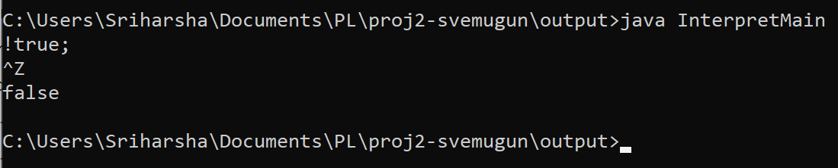

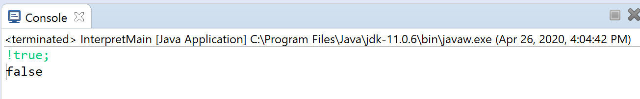

If-then-else Expression: if 18<42 then 18+42 else 42-18;

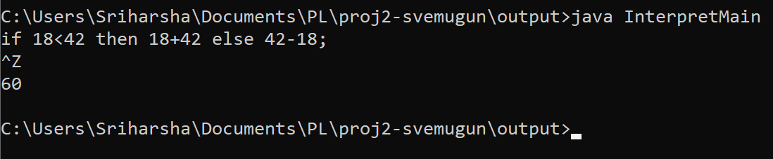

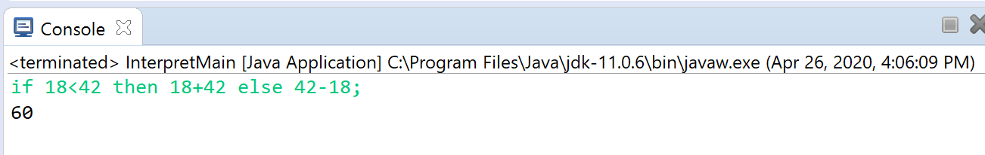

While-do Expression: let val x=2 in while x<5 do x:=x+3 end;

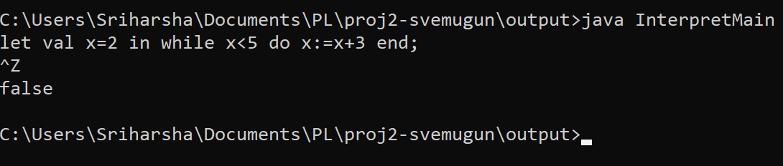

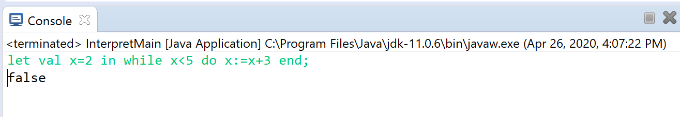

Let-val Expression: let val p=1997 in p:=p/1997 end;

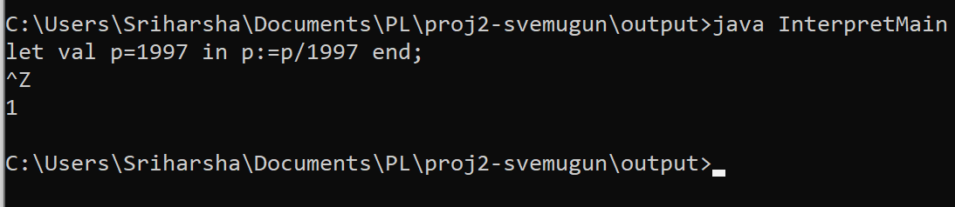

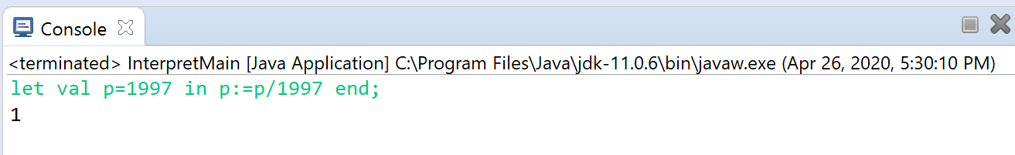

Sequence Expression: {1997-1842;1997+1842};

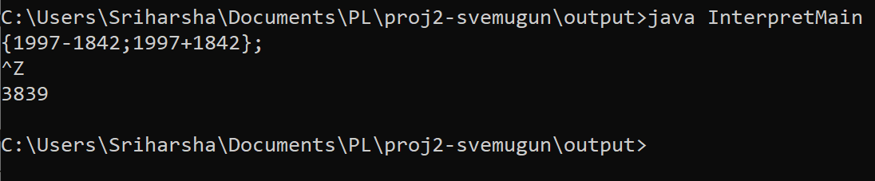

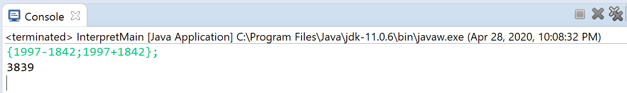

Let-fun Expression: (let val x=1 in (let fun f(n)=(n+x) in (let val x=2 in f(3) end) end) end);

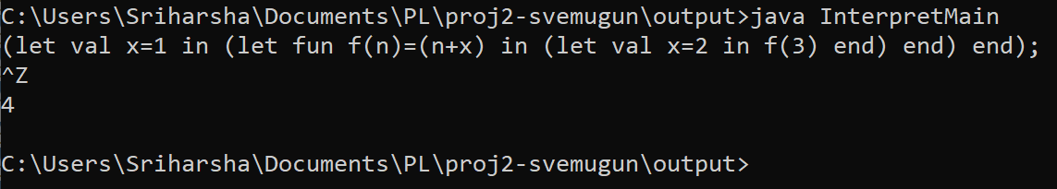

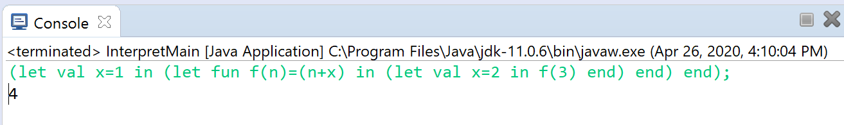

Integer Constant: 1842;

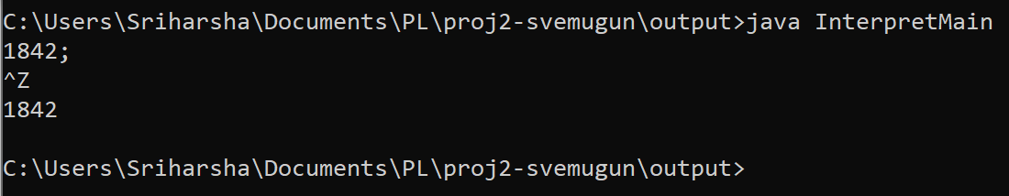

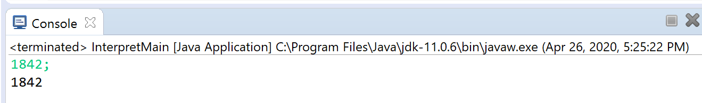

Boolean Constant: true;

